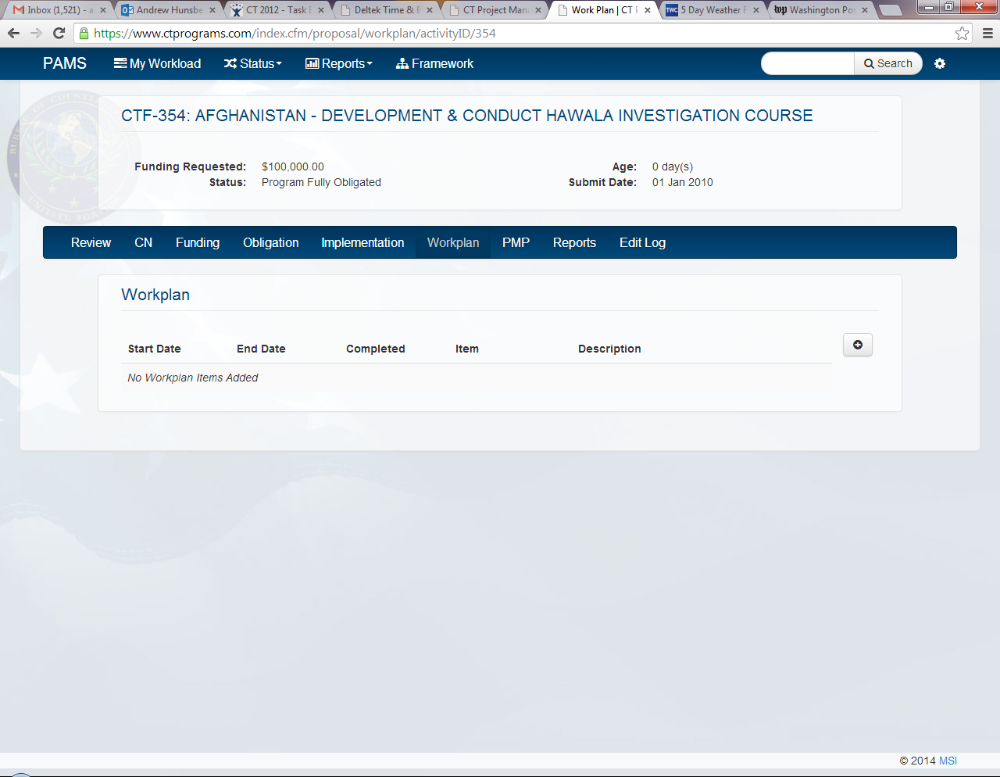Program Officers will log in to PAMS, access the project in question, and select the **“Workplan”** tab.

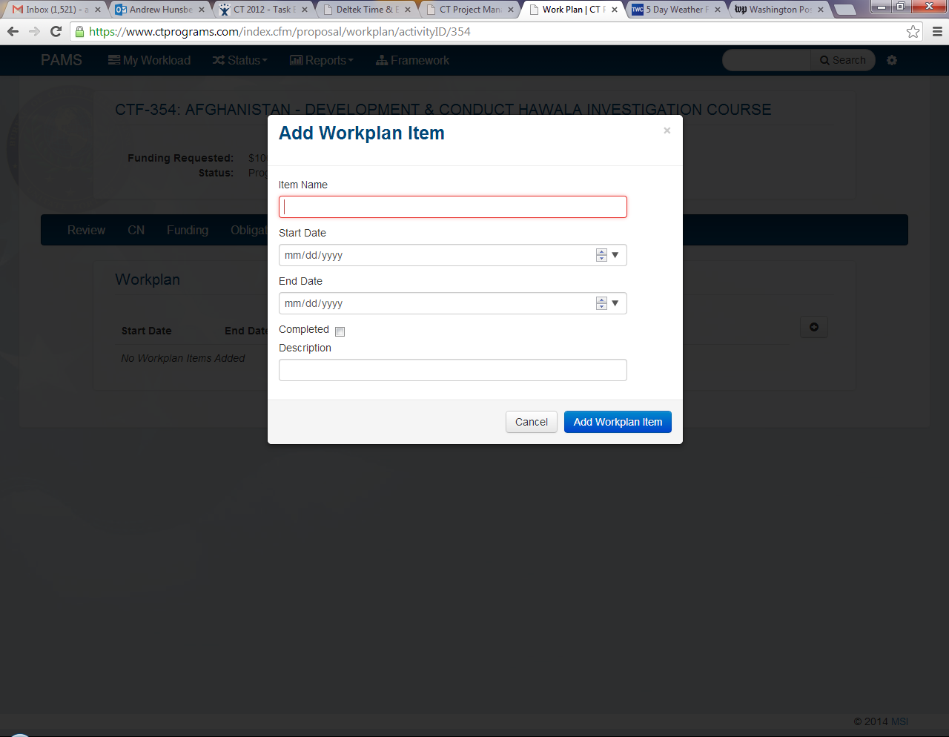Program Officers will select the “**Add Workplan”** button to create a new project workplan item.

Program Officers will enter a workplan item name, timeframe, and brief description. Once the workplan information has been entered, program officers will select “**Add Workplan Item**”.   
  
The PAMS Workplan page can support an unlimited amount of workplan items. Program officers may enter as many workplan items as are necessary for their project. Workplan items can be edited at any time via the Workplan page.   
 **\*\*\*NOTE**: Once a workplan item is completed, program officers should select the workplan item in question and check the **“Completed”** box.

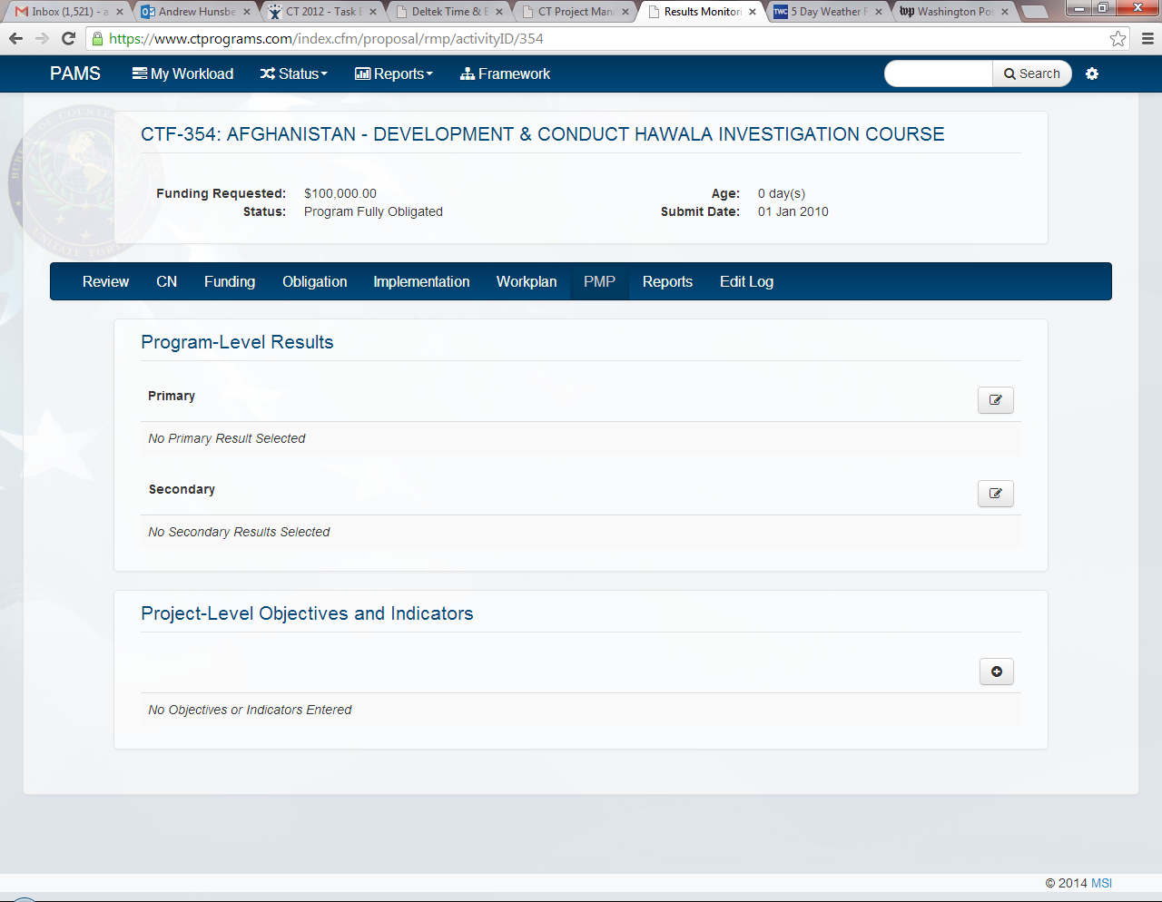Program Officers will log in to PAMS, access the project in question, and select the **“PMP”** tab

Program Officers will select the **“Program Results”** that are linked to their program RBM framework.

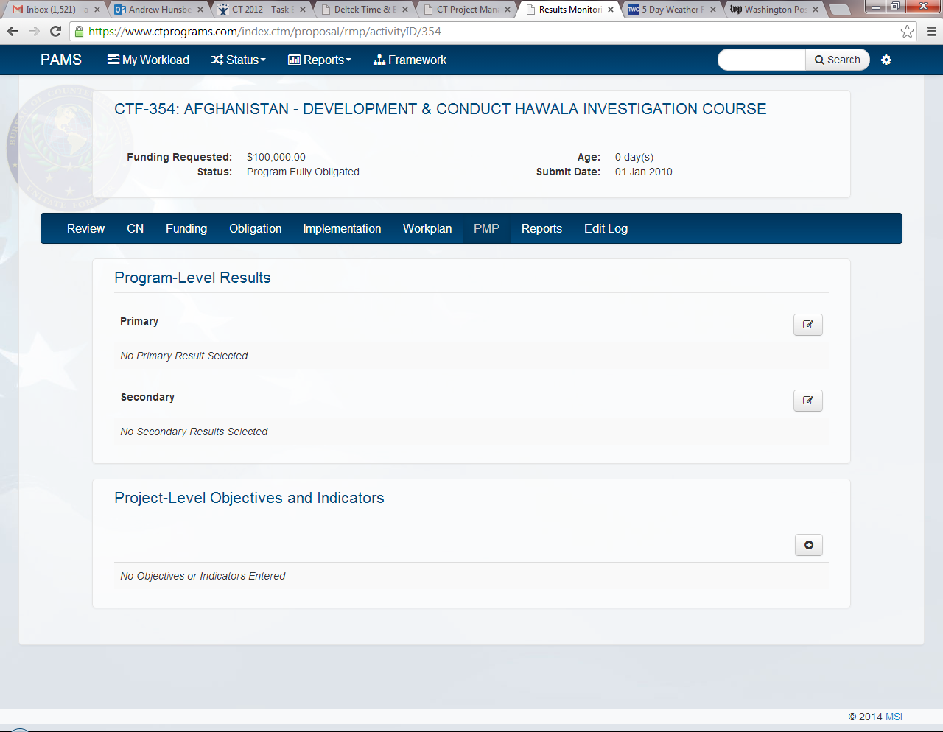Once the Program Results have been entered, Program Officers will enter “**Project-Level Objectives and Indicators”** by selecting the **“Add Objective and Indicators”** button.

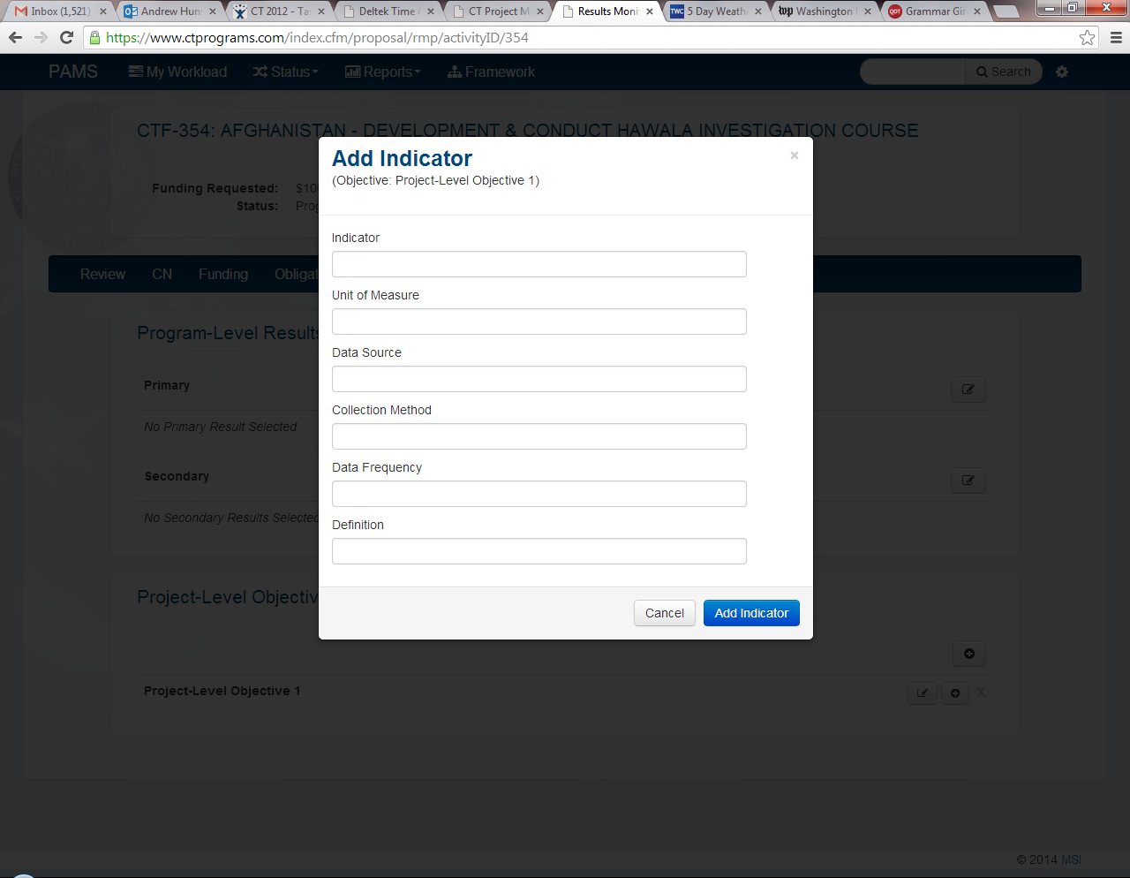Program Officers will enter an objective title, an indicator title, a unit of measure, the data source, the collection method, the frequency of data collection, and a brief definition of the indicator data. Once the project-level objective and indicator information has been entered, program officers will select   
“**Add Indicator”**.

**Add Objective and Indicator**

The PAMS PMP page can support an unlimited amount of project-level objectives and indicators. Program officers may enter as many project-level objectives and indicators as are necessary for their project. Project-level objectives and indicators can be edited at any time via the PMP page.